MULTIPLICATION UP TO 10
KS1 – 2007 Paper 1
1.
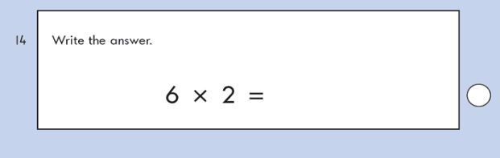
KS1 – 2009 Paper 1
2.
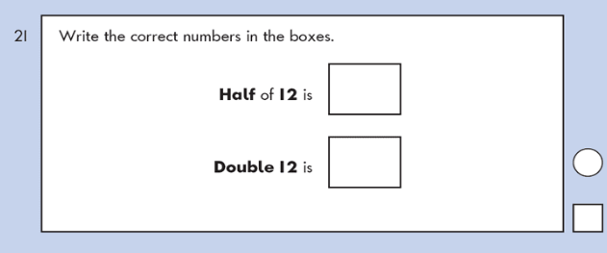
KS1 – 2016 Paper - Arithmetic
3.

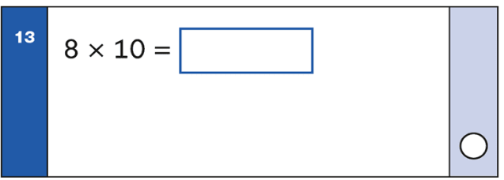
4.
5.
KS1 – 2016 Paper - Reasoning
6.

KS1 – 2016 Paper - Arithmetic (Second)
7.
KS1 – 2018 Paper – Arithmetic
8.
